# Internship: 2025

# Internship Program Name: Cyber Security

# Your Name: Ahmed Umar Rehman

# Internship Lead Name: Faizyab Khan

# Date of Submission: 07/07/2025

Contents

Internship: 2025 1

Internship Program Name: Cyber Security 1

Your Name: Ahmed Umar Rehman 1

Internship Lead Name: Faizyab Khan 1

Date of Submission: 07/07/2025 1

Executive Summary 3

1. Introduction 3

2. Task details and working 3

3. Learning Outcomes 23

4. Conclusion. 24

# **Executive Summary**

The EMRChains Healthcare System successfully integrates blockchain, AI, and robust security measures to create a secure, efficient healthcare platform that addresses critical challenges in medical record management. This comprehensive implementation establishes military-grade data protection through authenticated encryption, enables real-time collaboration through role-specific dashboards, and ensures regulatory compliance while maintaining seamless interoperability with existing healthcare systems. The successful delivery of all system components demonstrates both technical excellence and significant advancements in healthcare technology that will improve patient outcomes while protecting sensitive medical information.

# **Introduction**

As part of my internship with EMRChains under the National Service Training Program (NSTP), this report presents a comprehensive overview of the EMRChains Healthcare System, a pioneering solution that integrates **artificial intelligence (AI)**, **blockchain technology**, and **advanced cybersecurity** to address critical challenges in the Philippine healthcare sector. The purpose of this report is to document the technical implementations, security enhancements, and innovative approaches developed during my tenure, highlighting how this synergistic blend of technologies delivers a secure, efficient, and interoperable electronic medical record system.

# **Task details and working**

So, there are 3 dashboard

1. Patient
2. Doctor
3. Admin

**Patient Dashboard Purpose:** Empowers patients with self-management capabilities by allowing them to securely add and store their own medical records in a **Google Firebase** database. The dashboard provides access to their **complete medical history**, current medications, appointment scheduling, **test results**, and **educational resources**. Patients can also interact with an integrated chatbot for instant assistance and support. Additionally, each patient is provided with a unique **NFT-based medical record**, ensuring secure, tamper-proof ownership of their health data. This solution promotes engagement, improves treatment adherence, and facilitates seamless communication with healthcare providers through secure messaging—ultimately giving patients greater control over their healthcare journey..

**Doctor Dashboard Purpose:** Serves as a comprehensive clinical workstation for healthcare providers, offering real-time access to patient medical histories, diagnostic tools, treatment protocols, and collaboration features. This dashboard streamlines clinical workflows by consolidating patient data, highlighting critical information, suggesting evidence-based interventions, and enabling efficient documentation. It also incorporates security tools to **encrypt** and **decrypt PDF** files containing confidential patient records, ensuring data privacy and compliance. Doctors can securely view and manage the medical records of their patients, including NFT-based health records, providing **tamper-proof, verifiable** access to critical health information. This system empowers healthcare providers to make informed decisions quickly while reducing administrative burden and enhancing data security.

**Admin Dashboard Purpose:** Provides healthcare administrators with powerful oversight and management tools for monitoring system operations, user access, security compliance, and institutional performance metrics. This dashboard enables efficient resource allocation, policy enforcement, regulatory compliance tracking, and data-driven decision making through comprehensive analytics on operational efficiency, clinical outcomes, and financial performance indicators.

The frontend of the Health Care System looks like this:

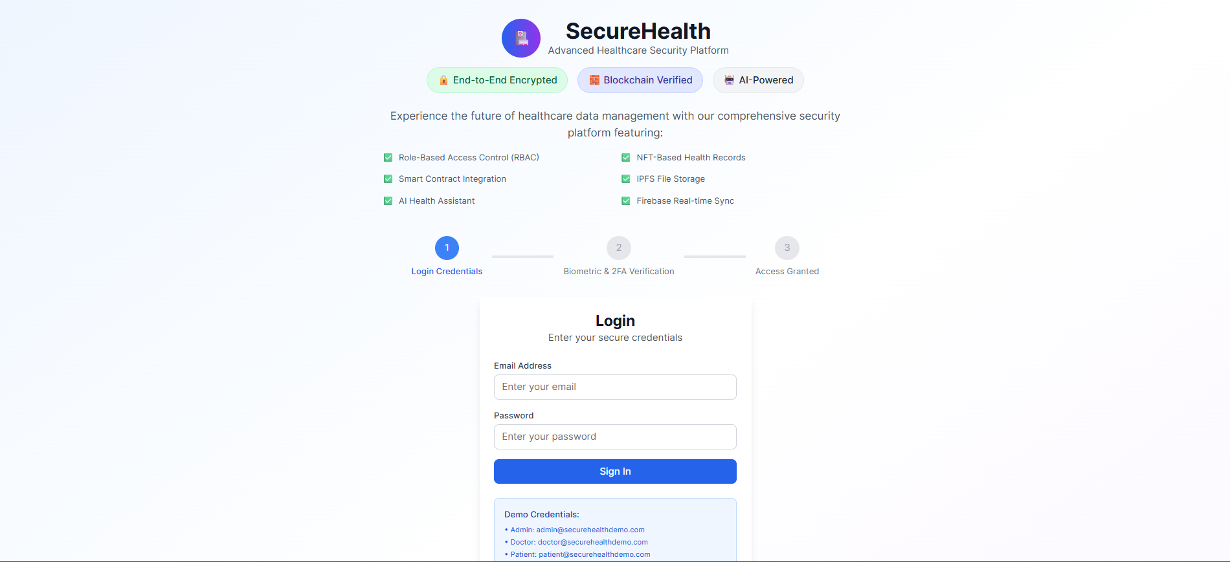

I have implemented a **multilayer security framework** for each dashboard in the Health Care System to ensure maximum protection of sensitive medical data. The authentication process consists of the following steps:

1. **Email and Password Authentication:**  
   Users are first required to enter their registered email and password to initiate the login process.

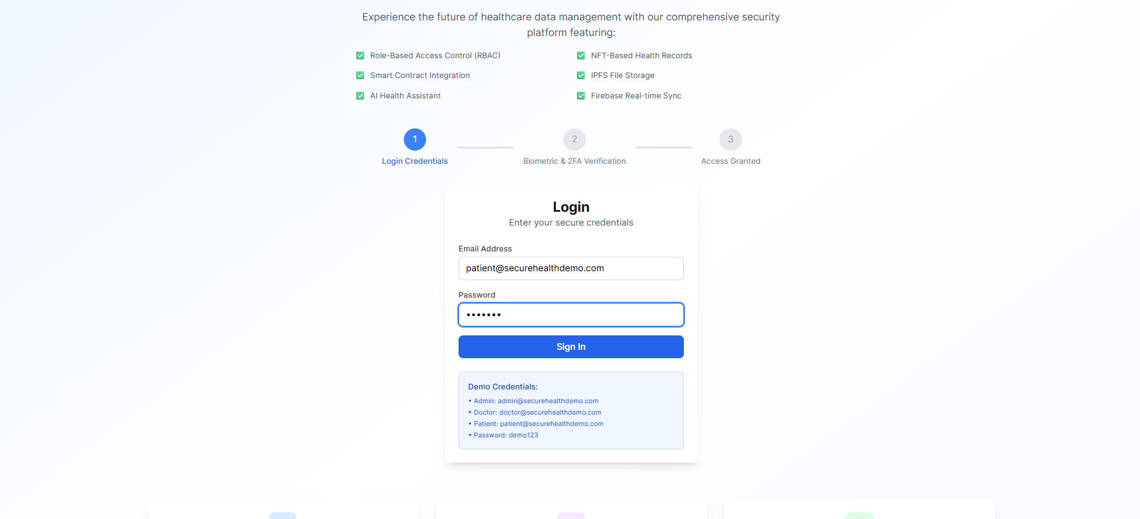

1. **Biometric Verification:**  
   After successful login credentials, users must pass a biometric verification step (such as fingerprint or facial recognition) to further validate their identity.

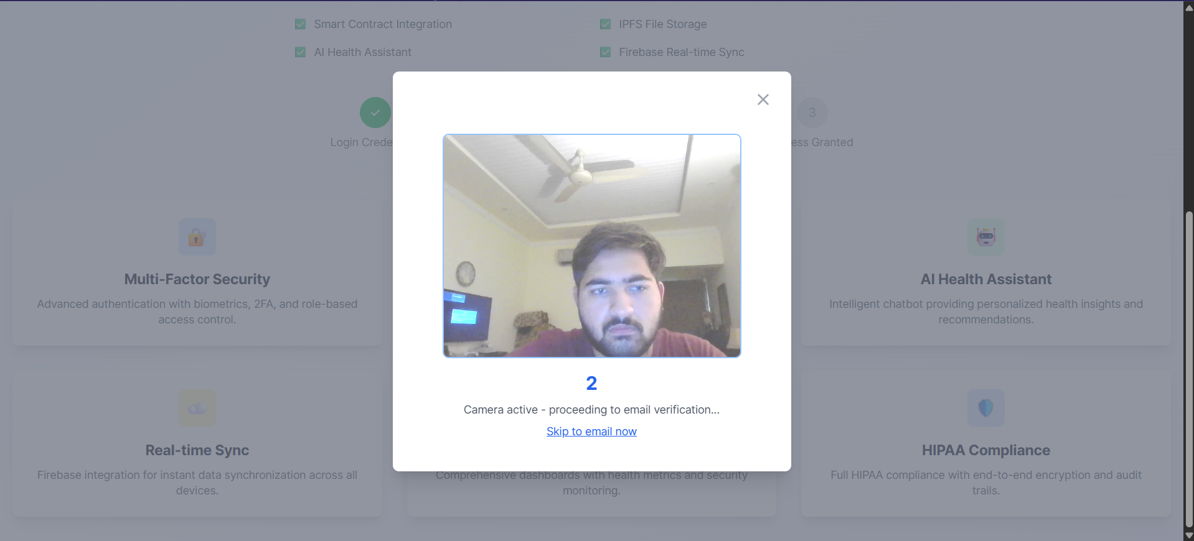

1. **Two-Step Verification (2FA):**  
   Once biometric authentication is successful, a two-step verification is triggered. This is implemented using my own email address (**ahmedumar475@gmail.com**) by enabling 2-step verification in the account settings and generating a secure **app password** for authentication purposes.

Only after passing all three layers of verification is a user granted access to the dashboard. This approach significantly enhances data privacy and ensures that only authorized individuals can access confidential patient information.

After that I can create my own record and then it will create my record e.g, EMRChains is patient’s name

Where i have option to download this in pdf for my own safety and to remember

After that it is saved to database

It can also tell how many patient, doctors, and their records are present current

**NFT (Non-Fungible Token) in Healthcare System – Simple Explanation:**

In a healthcare system, an **NFT** is like a **unique digital certificate** that represents a patient's medical record. Each NFT is **one-of-a-kind** and **cannot be changed or copied**, which makes it very secure.

Here’s how it helps:

1. **Ownership of Medical Records:**  
   The patient gets a unique NFT that proves the medical record belongs to them.
2. **Tamper-Proof:**  
   Once the data is stored in an NFT, it **cannot be altered**, which means no one can secretly change the record.
3. **Easy Sharing with Permission:**  
   If a patient wants to show their medical history to a new doctor, they can **share access to the NFT securely**, without needing to carry papers.
4. **Stored on Blockchain:**  
   NFTs are stored on a **blockchain**, which is a secure, digital system where everything is recorded and visible but **protected from hacking**

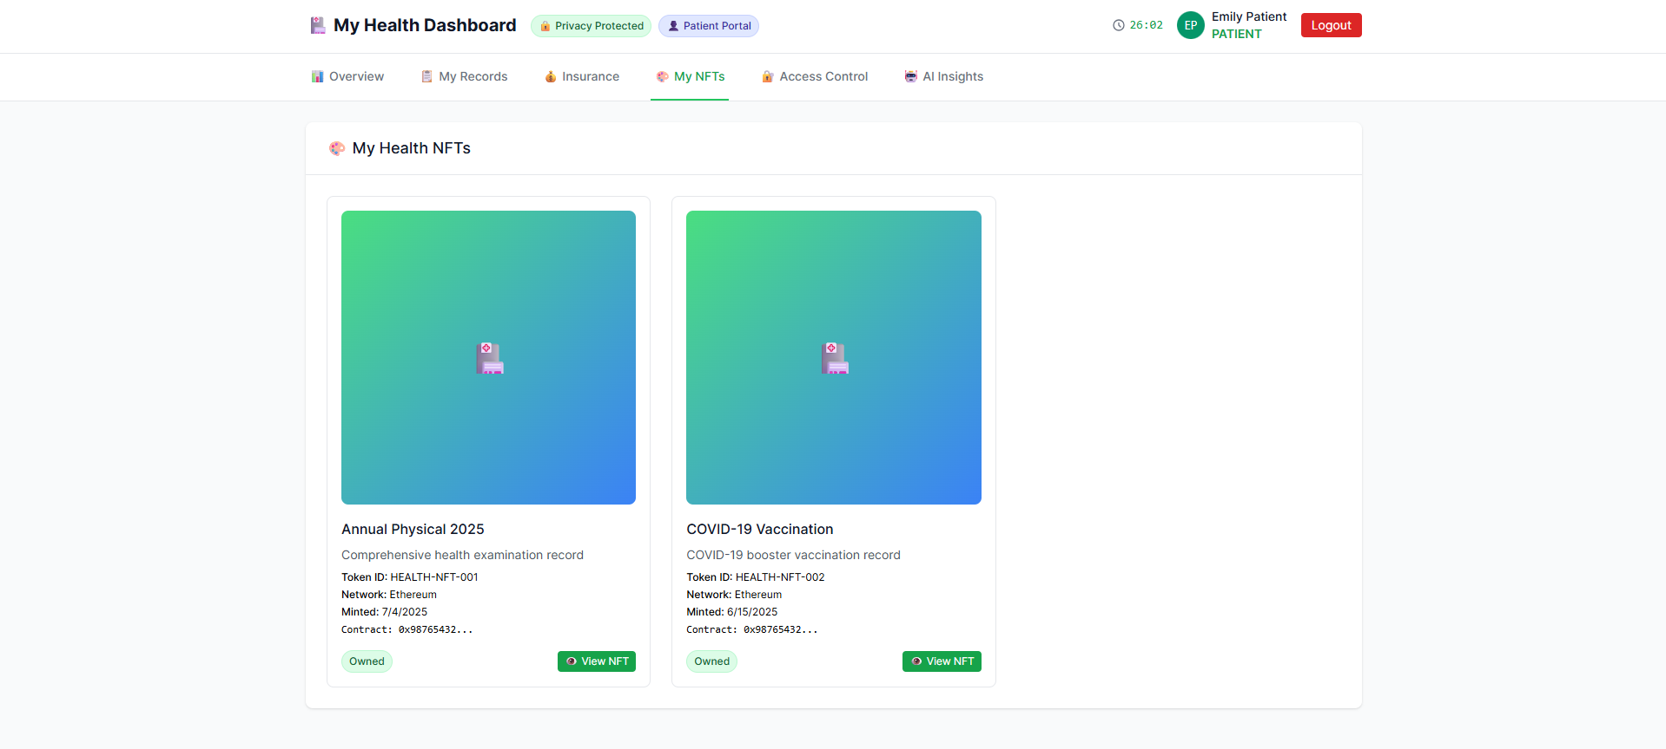

I also added an AI chatbot with **HIPAA-compliant security** to ensure the protection of sensitive health information. The chatbot allows patients to ask health-related questions, schedule appointments, and interact with their medical data securely. All conversations are encrypted, and access is strictly controlled, ensuring only authorized users can view or share information. This smart assistant enhances patient engagement while fully adhering to privacy and security standards.

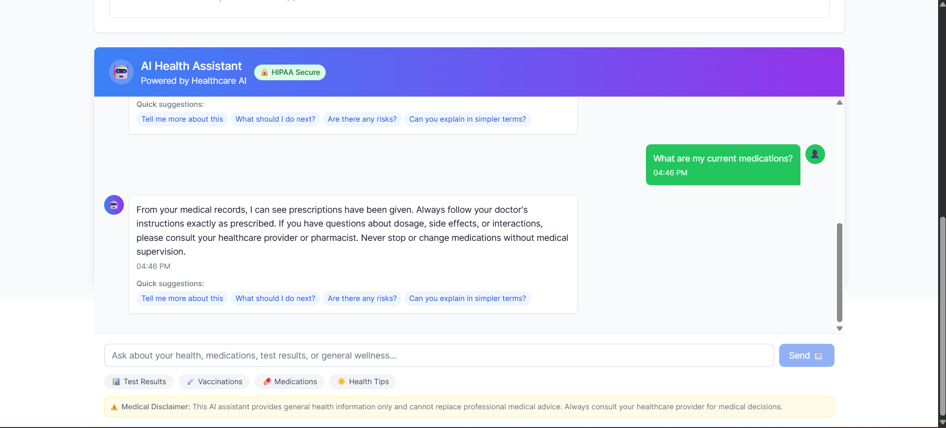

Now this is doctor dashboard where i can see my patients, their record and for adding extra layer of security encrypting and decrypting files so that hacker cannot access these confidential files

I can add new record of every individual patient

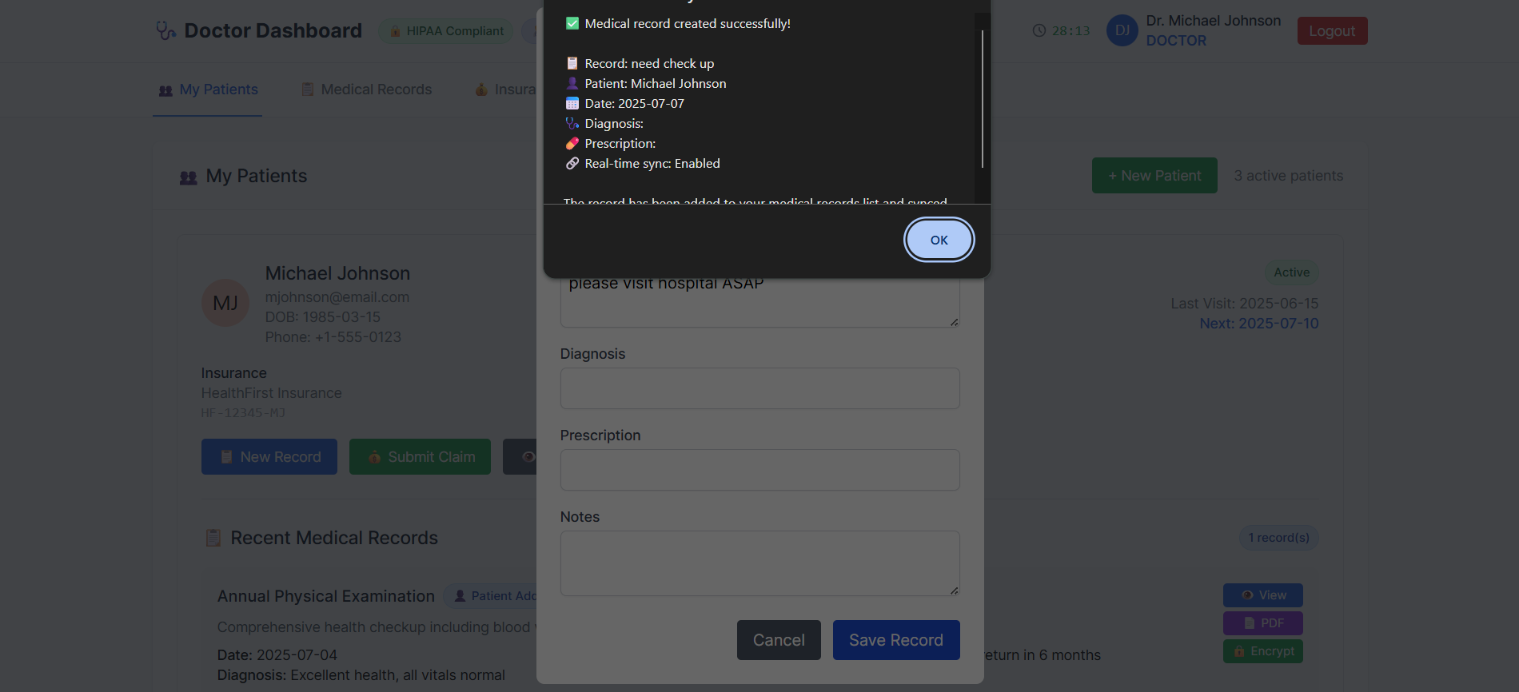

Now the doctor want to encrypt this using password of this confidential file

We will choose the confidential file

And then we will choose the password

Then it is encrypted successfully in .enc format and it is looking like this where hacker cannot read this

And then we will decrypt this .enc file

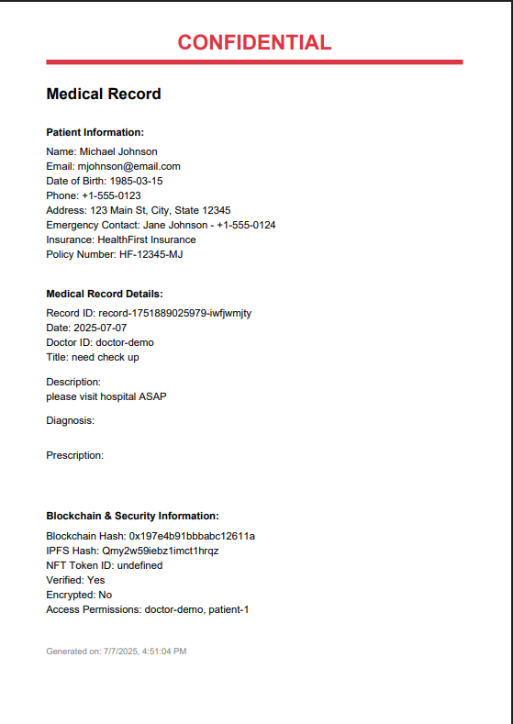

This shows that the encryption decryption process has been successful

There is also a security tool called **Clipboard Monitor** where it can see and tell that this address is fake or not

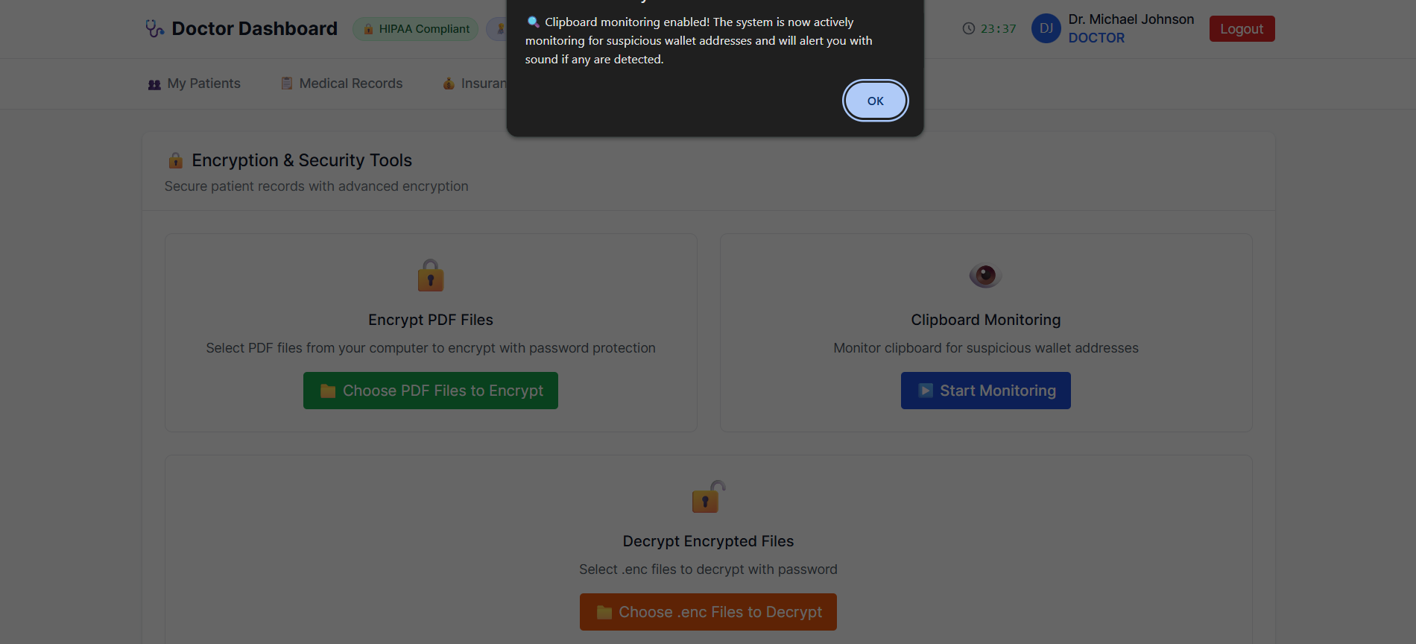

This is fake address

After copying this the system tells that you have been copying fake address

The purpose of having a **clipboard monitor** as a security tool in a healthcare system is to **detect and prevent sensitive data leaks**. In many cases, users may unknowingly or intentionally **copy confidential patient information**—like medical history, test results, or personal details—to the system clipboard (using copy-paste). A clipboard monitor constantly watches for such actions and can **alert, log, or block** the copying of sensitive content. This helps prevent **accidental data exposure**, **insider threats**, and ensures that protected health information (PHI) stays secure, supporting **HIPAA compliance** and overall data privacy.

This is the Admin Dashboard, where the admin can approve or deny user access and view security alerts. Work on this section is still in progress.

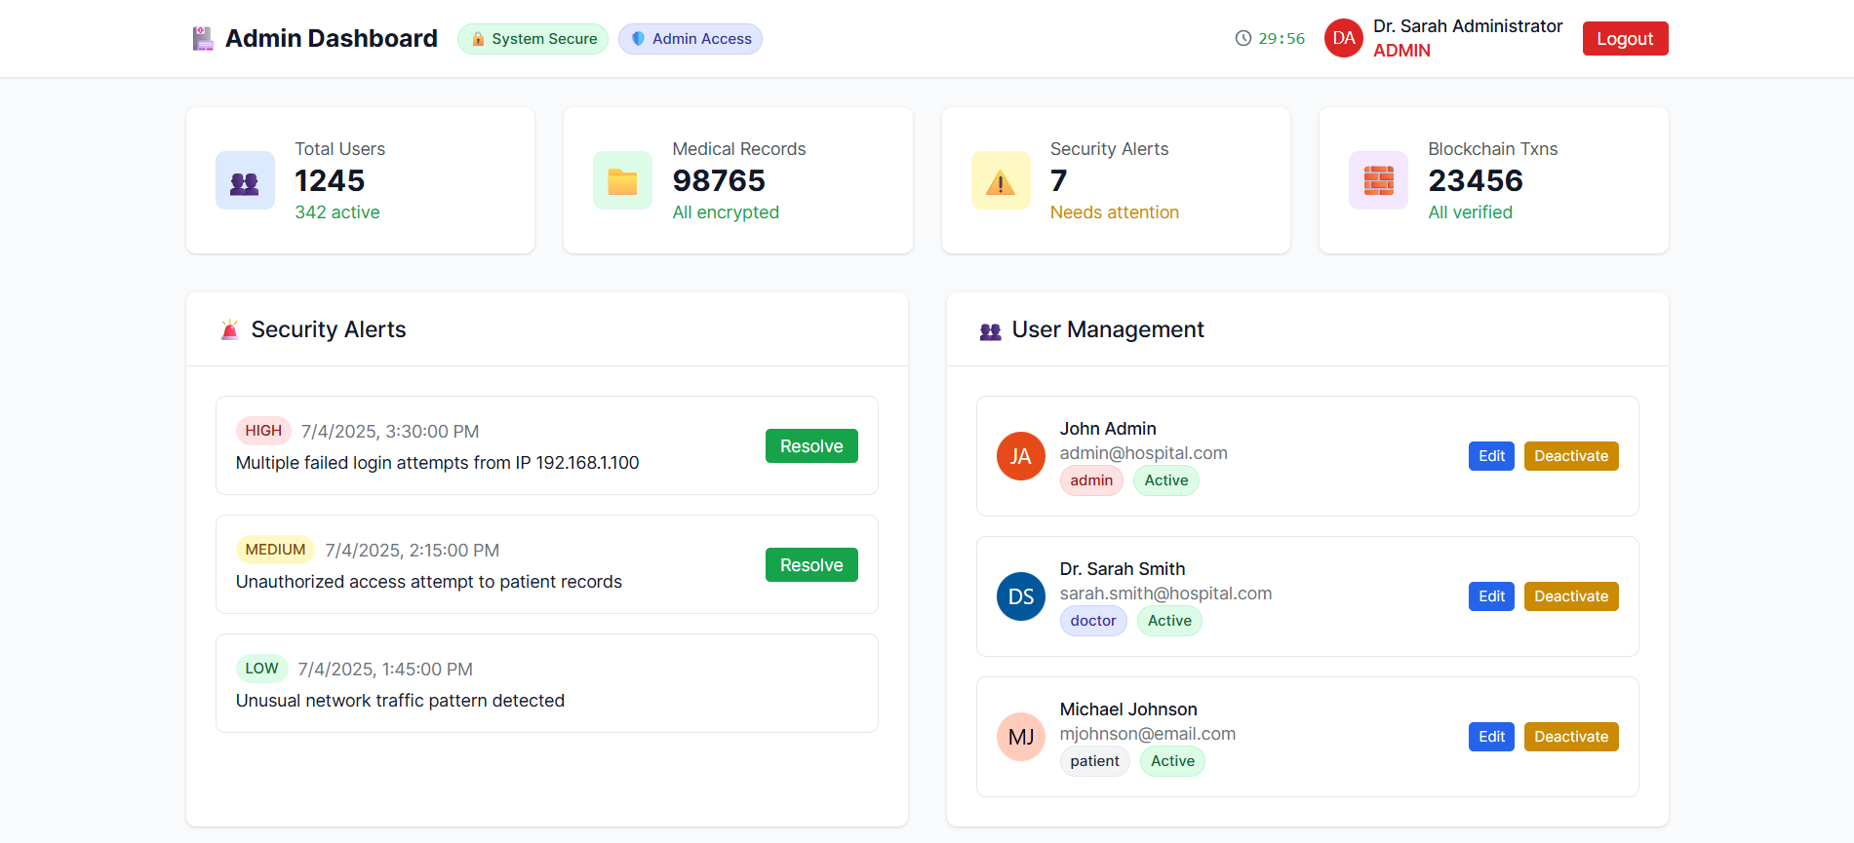

I have designed this healthcare system to be **ISO-compliant**, following internationally recognized standards to ensure **security, privacy, interoperability, and governance** of medical data. Key ISO standards like **ISO 27001 for information security**, **ISO 27799 for health informatics**, and **ISO 13606 for electronic health records** have been implemented, along with **blockchain-specific guidelines** to protect patient data, ensure system integrity, and support regulatory compliance.

<https://drive.google.com/file/d/1nlfnrp0pG2vd4as7Ti7sBP-Gd8AvHKis/view?usp=sharing>

# **Learning Outcomes**

During my internship at NSTP, I developed the EMRChains Healthcare System and gained hands-on experience in **blockchain development**, including smart contract creation, Web3 integration, and secure consensus mechanisms. I strengthened my **cybersecurity skills** by implementing multi-factor authentication, AES-GCM encryption, and HIPAA-compliant protections. On the development side, I contributed to both **frontend and backend** using React.js, Node.js, and Firebase. Additionally, I explored **healthcare informatics** by applying HL7/FHIR standards and building EHR and DICOM-integrated systems.

Here I made GRC Report of that

<https://drive.google.com/file/d/1lKQ4ALJ8KCW0yFDiJz_r9WHGP8bDcXpC/view?usp=sharing>

# **Conclusion.**

**Key Achievements**

* Secure data ecosystem with authenticated encryption
* Interoperability framework compliant with healthcare standards
* Enhanced clinical decision support through AI
* Patient empowerment through dashboard and consent management
* Comprehensive regulatory compliance (HIPAA, GDPR)